STARR LIBRARY
LONG RANGE PLAN
BACKGROUND, MISSION AND VISION, VALUES

BACKGROUND
Incorporated in 1862 as the Starr Institute, today’s Starr Library is an Association Library under the laws of New York State and is a 501(c)(3) organization under federal tax laws. Principal funding is through a “Chapter 414” referendum approved by Rhinebeck voters, supplemented by grants, annual donations, and interest on gifts held in an endowment fund, as required by Starr bylaws.
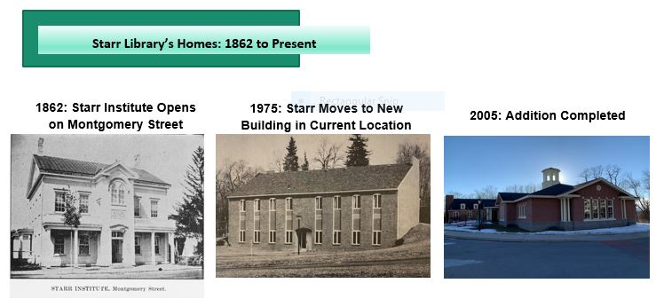
From 1862 until 1975, the Starr Institute was housed in the heart of the Village in a building on Montgomery Street of the same name. In 1975 the library was moved to its present location on a hill at the western edge of the Village, where a new two-story library building was erected on a parcel now owned by the library. In 2005, the library was enlarged with a one-story east-facing addition that serves as the main entrance. The two buildings combined cover 11,000 square feet and about what is now the entrance to the Thompson-Mazzarella Park.

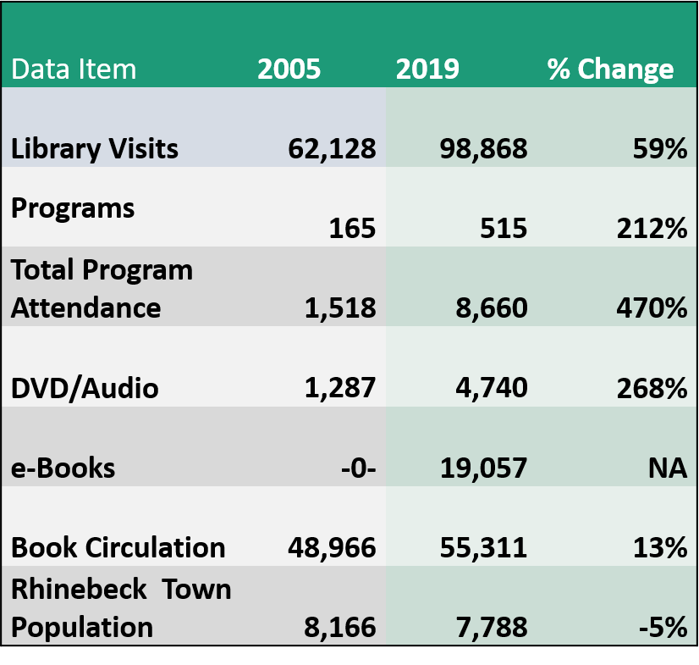
In the past 15 years, the role of Starr Library—as with many public libraries—has changed in many ways, serving increasingly as a community center. As shown in the table to the right, the number of programs held at Starr more than doubled between 2019 and 2005, and total attendance has increased nearly fivefold. The number of annual library visits has also increased steadily to just under 100,000.

Nearly 20,000 e-books circulated in 2019, while in 2005 there were none. Surprisingly, book circulation has increased since 2005, despite the growing popularity of electronic resources.

Pre COVID, Starr Library has been a busy place: About 25 community groups use Starr Library for meetings, among them Friends of Starr Library and the Rhinebeck Historical Society. Although use has expanded, the building has not.

Developing the Long Range Plan
In 2019, the Starr Library Board of Trustees determined that a new comprehensive long-range plan was needed for all aspects of the library (e.g., operations, programs, finances, and partnerships), including the facility. A long-range plan subcommittee, composed of Board and staff, was formed in September 2019 to coordinate the planning process. Staff and Board engaged in a two-year information gathering process (2019-2021) to identify needs and priorities, using a combination of surveys, stakeholder interviews, and online community forums that reached more than 600 patrons and residents. Guided by robust community input, Board and staff then worked collaboratively to create a new vision statement and values to guide the long range plan. In turn, these led to formulation of objectives and specific actions in 10 goal areas (2021-2025).
In 2020, with generous financial assistance from the Friends of Starr Library, the Board hired architect Paul Mays, a partner in the firm Butler Rowland Mays Architects, LLP and a specialist in library design, to complete a building assessment report and worked with Mays to engage the community in determining the need for a building renovation or expansion.
Identifying Starr’s Needs and Priorities
To assess needs and priorities, Starr Trustees and staff committed to collecting information from multiple sources and undertook the following seven actions:

- Comparisons
We compared Starr operations (e.g., circulation, program attendance) with data available for the 65 libraries in the Mid-Hudson Library System. Board members also reviewed program offerings at other libraries.
- Area Library Tours
Board members toured recently renovated area libraries to collect ideas and observe renovations, many completed by architect Mays. Libraries included those in Kingston, Stanfordville, Kinderhook, Claverack, and others.
- Consultations with Key Officials and User Groups
Trustees and staff met in fall 2019 with the Friends of Starr Library, the Rhinebeck Historic Society, government officials, and other user groups.
- In-House Survey
An electronic survey was administered to 30 staff members, Trustees and Friends in December 2019 and January 2020 on library use, patron experience, and space assets and limitations.
- Stakeholder Interviews
In late February and early March 2020, architect Paul Mays conducted individual face-to-face interviews with 28 community stakeholders and a follow-up Zoom session in July 2020.
- Community Survey 2020

In August 2020, an electronic survey was created to gather information from the community on future needs and priorities. The survey was launched in October 2020 and over 500 responses were received. (Include active link to survey report here )
- Virtual Community Forums with Architect Paul Mays

Four virtual forums took place in late January and early February 2021 to inform the community about the survey results and to show how Mr. Mays has used community-generated ideas like those provided in the survey as a basis for expanding or renovating other libraries.
STARR MISSION
Starr Library shall provide access to the highest quality library services and programming, enriching our lives and building community.
STARR VISION 2026
Serving Rhinebeck for more than 150 years, Starr library will become a destination that inspires learning, creativity, and civic engagement, broadening its role as a place for our community to gather and connect.
STARR VALUES
1. Crossroads of the Community
Located on the edge of the Village, Starr Library is in the heart of the community, serving as a hub for patrons, residents, businesses, visitors, and many community groups. The library shall reflect the vibrant character of Rhinebeck, acknowledging the contributions of the many peoples who have contributed to the village and town during 400 years of history.

2. Welcoming and Inclusive
Starr strives to be welcoming to all members of our community and to represent the diversity of our community through our services, collections, programs, staff, volunteers, and governing board.

3. Accessible
Starr shall provide ways to make it easier for all patrons to navigate our facility and use our physical and virtual resources and programs.

4. Dedicated to Literacy and Lifelong Learning
Starr shall provide a literacy-rich environment with diverse opportunities for lifelong learning. Starr’s resources support literacies essential for engaged citizens: reading, writing and communication skills, as well as media, civic, multicultural, and financial literacy.

5. A Trusted Source of Information
Starr shall provide vital information services, adapting to current technology. Starr serves as a neutral source of civic and community news, essential for an informed citizenry

6. Technologically Forward
Starr will remain at the forefront of technology advances by continuously upgrading its computers, Wi-Fi and software, while increasing digital inclusion through training and lending technology equipment.

7. Socially Responsible
Starr Library shall share responsibility with other public and community organizations for the well-being of all, lending support, within our mission, to address urgent and emerging needs.

8. Collaborative
Starr Library seeks an active role in the community and in planning for its future. Starr works proactively to partner with other organizations to enrich library services and programs.

9. Accountable for Excellence
Starr Library staff and board strive to achieve excellence in all operations, and to be accountable in providing quality services responsive to the community.

10. Committed to Sustainability
Starr is dedicated to the library’s institutional, financial, and environmental sustainability.

STARR LIBRARY
LONG RANGE PLAN
STARR GOALS AND OBJECTIVES 2021-2025

- Welcoming Everyone
Starr is a welcoming place for everyone and will continue to reduce barriers that may limit access to library services.

- Based on Starr surveys and community information, Starr Board and staff will convene annually to identify underserved populations and others in need of services to inform service delivery and program planning.

- Starr library will Increase collaboration with other organizations and libraries to promote equity and inclusion, extending the reach of library services in the community.
- Starr facility spaces, programs, and collections will be adapted to accommodate the needs of diverse users. Starting in 2022, patrons will have access increasingly to more diverse stories, programs, and experiences.
2. Striving to Serve All Members of the Community Equitably
Starr strives to serve all members of our community equitably and will embed justice, equity, diversity and inclusion (JEDI) goals in all Starr operations.

- Starr staff and Board members will complete a JEDI assessment in spring 2022, using tools available through NYCON, MHLS or other organizations.
- All Starr staff, volunteers and Board members will participate in JEDI training, starting in 2022, and will be responsive to the diverse character and needs of our community.
- Starr Board and staff will implement an action plan by 2023 to represent diversity among staff, volunteers, Friends, Board, and contracted services.
3. Increasing Resources for Children and Families
Starr will expand programs and resources for children and youth of all abilities, in partnership with child-centered institutions in the community.

- With the addition of a ½ time children’s programmer, Starr will increase children’s programs, especially literacy-based offerings.
- Starr will strengthen and expand partnerships in 2022-2023 with child-centered organizations, including RCSD librarians and Astor Home, local homeschool groups, pre-schools, parent/child groups, and ESL programs.
- In 2022, Starr will explore creation of a teen advisory board to inform increased teen activities and future space renovation/expansion.
- Starr will complete a JEDI assessment of the children’s collection in 2022 and will increase the diversity of collections for children and youth, including the bilingual collection, over three years.
- Starr will improve space configuration and furnishings in the children’s area, by reserving the children’s area exclusively for children and relocating adult programs to the lower level (slated for rehabilitation in 2022).
4. Supporting the Well-Being of Our Community
Starr will promote health, education, financial and civic literacy among adults of all ages and serve as an active partner to support the welfare of our community.
- Starr will plan programs, services, and collections for all adults and for selected target groups, based on community needs, updated annually by Board and staff.

- Starr will ensure that its adult services, spaces, furnishings, collections, and materials reflect JEDI and special needs standards.
- Funds will be allocated to Increase foreign language materials by December 2022
- The community room will be made more welcoming and available to the community in 2022.
- Starr will investigate the need to contract for social worker services by 2023 and beyond.
- Starr will partner with municipal and community organizations to ensure the well-being of the community and respond to emergency needs. Topics may include:
- Voter registration, Medicare information, JEDI and racism discussions, fire safety and emergency response/EMT practices, renewed staff CRP/AED training, community Narcan training.
5. Raising the Visibility of Starr in the Community
Starr will enhance its visibility as a hub of the community both in the community at large and among specific populations.
- Starr staff and the Board PR Committee will Increase Starr’s visibility in the center of Rhinebeck in 2022 and beyond:
  - Install 2 additional little free libraries in RBK center in 2022
  - Install 2 story walks on Thompson-Mazzarella Park in 2022.
  - Explore creating a Starr bulletin board in central Rhinebeck.
- Starr will publicize its services and events through a diversity of digital and traditional media, and will:
- Increase the frequency and variety of messages sent to Starr’s email list of over 2500 individuals and organizations, starting in 2021 and thereafter, and highlight Starr’s role organizing and assisting community events.
- Explore distribution of posters and card in storefronts, on bulletin boards, in weekly pick-up bags at food pantries, at Farmers Market and events.
- Promote Starr at large community events, including Porchfest, Sinterklass, Holiday Lighting, Memorial and Veteran’s Day, or cultural celebrations. Consider tie-in programming at Starr before or during these events.
- Focus outreach on newcomers and historically underserved populations, developing outreach strategies for target groups selected annually.

- In selected years, the Board PR Committee will create 414 promotion and outreach plan.

6. Maintaining an Attractive, Technology-Forward and Accessible Facility
Starr will maintain an attractive, technology-rich environment and improve accessibility, while also planning for a major renovation/expansion by 2026.
- Increase the budget to keep pace with technology advances in equipment, Wi-Fi, and software. Improve technical assistance to patrons by increasing staff technology competencies.
- Increase accessibility to the Starr building by improving ADA compliant parking, curb access, and installing new front doors. Hire an ADA consultant in 2022 to advise on improvements.
- Make the lower level community room a more welcoming space for programming and community groups by completing a facelift by mid-2022.
- Develop a plan by June 2022 to create more inviting and useful outdoor gathering spaces.
- Maintain linkages with the Village and Town of Rhinebeck, and TTMP Committee to improve the Starr and Park entrance as a more welcoming space.
- Based on community needs gathered from 2019 to 2021, Starr will present architectural plans to renovate/expand the facility to the community in 2022 and initiate a capital campaign.
7. Planning for Starr’s Financial Future
Starr will implement a diversified fundraising plan, including regular 414 requests, to support the needs of the library and will continue to grow a secure endowment that generates operating revenue.
- Starr will implement a five-year financial plan for operations and routine capital improvements.
- Starr will submit at least two grant applications each year, beginning in March 2022.
- Starr will Increase individual and institutional contributions by at least 5% in 2021 and annually thereafter
- Starr will seek bi-annual 414 tax increases sufficient to cover projected operating expenses.
- Starr will allocate funds to perform regular audits of library finances.
8. Optimizing Staff Talent and Supporting Professional Development
Starr staff will have the competencies needed to meet or exceed LRP goals and 2021 NYS library standards and will have access to paid professional development opportunities.
- Identify staff competencies and professional development needed to meet 2021–2025 goals.
- By spring 2022, Starr Board and Director will recommend realignment of work assignments to optimize talents, drawing on volunteers, technical services consultant or other resources.
- Starr Board will assess salaries, wage rates and total compensation against comparable area libraries and make adjustments, as needed for the 2023 budget.
- Starr Director will build a pool of trained hourly workers to serve as on-call substitutes for the circulation desk.
9. Building a Dynamic and Diverse Board of Trustees
The Starr Board will develop into a dynamic group with capacity to achieve LRP goals and meet or exceed 2021 New York State Library Standards.

- The Board will conduct a 5-year review of Starr bylaws and amend to clarify roles, responsibilities and communications.
- Effective January 2022, the Board will review four Starr policies each quarter and identify changes needed.
- All Board members will complete at least one MHLS training each year and new Board members will complete Trustee training within six-months of starting their term.
- To keep abreast of Starr’s engagement with the community, Board members will subscribe to the Starr email distribution list and review both Starr website and Facebook postings monthly. Board members will visit the library in person monthly and attend at least four Starr programs or events annually.
- The Nominating Committee will develop a Trustee replacement plan consistent with a JEDI Board plan.
- Starr Governance Committee will conduct Board self-evaluation in November every year.

10. Evaluating Starr’s Services and Effectiveness
Starr will assess needs of the community and specific populations annually and evaluate library services and their effectiveness.

- Starr will implement new recordkeeping, survey, and reporting protocols to document and evaluate services.
- Starr will conduct patron surveys to assess satisfaction with Starr programs and services and patron knowledge and use of Starr resources.
- Starr will evaluate progress on these measurable objectives:
- Increase in Starr Library card holders over previous year.
- Increase use of collections by card holders, as measured by MHLS data.
- Increase community collaborations over previous year, as measured by the # of community groups using the library, and the # of external groups co-sponsoring or leading programs.
- Increase program participation by youth and adults over previous year, as measured by program attendance data for the calendar year.

*This document is a summary of goals, objectives and selected actions. Over 100 specific actions are included in a detailed workplan with timelines.

